Cave Profile

Date: Cave Name: Takream Cave
Commune: District: Province:
Recorder: Cave Coordinates:
Harvesters:

Harvesting:
1. How many years has guano been harvested from the cave? What year did it begin?

2. Has the cave always been harvested for guano by the same people since it began?

3. How often is the cave harvested now (times per month) and how many people harvest it each time? (Do they all harvest at the same time or separately at different times?)

4. How much guano is collected by each person each time, and, how much altogether?
(Record no. of rice-sacks or other container and how many kilograms each one weights; if exact amounts aren’t known, ask for a lower and upper range for both)

5. How long does each harvest take and what time of day/night does it happen at?

6. Does the amount of harvesting and quantity harvested change between the dry and wet seasons? If so, can you please explain how?

7. Does the time or season of harvesting have any effect on the quality of guano? If yes, can you please explain how and if any other factors affect guano quality?

8. How many bats would you say live in the cave? Has the number of bats stayed the same since the harvesting began? Also, does it change between the dry and wet seasons?

9. Has the harvesting always occurred at the current level? If no, how and when did it change (i.e. increase/decrease) and how long has it been at the current level?

Management:

10. Are detailed records kept of each harvest? If yes, how long have these been kept for?

11. Has the situation for management (ownership) and protecting the cave changed since the harvesting began? If so, can you please explain how? (If the harvesters pay a license fee, ask for details of how long for, how much it costs, and who they pay it to)

12. Do the bats breed once or twice a year (i.e. when the young appear) and when does this occur?

13. Have you ever noticed large numbers of dead bats in/around the cave? If so, when did you see this and what do you think caused it?

14. Were there any threats to the bats in the past? If so, what were these and how serious was each threat? Were these dealt with and if so, can you tell us how?

15. Are there any current threats to the bats and are they different in any way from before? If so, how and why have they changed? What are the most serious threats now and why is this? (Think about possible on-site and off-site threats when asking these questions)

16. If yes to the above, is there anything that can be done about these threats? Would outside assistance help you to deal with these? If yes, what help would you like?

Post-Harvest:

17. Once harvested, what happens to the guano? How is it stored and is it processed in any way before and during storage?

18. How much of the guano do you use directly/personally and how much do you sell? (simple percentages will do here)

19. Do you do any kind of advertising to attract buyers for your guano? If yes, what kind?

20. What do the end-users of the guano use it for? E.g. what crops is it used for?

21. How do you think bat guano compares to other types of available fertilizer in terms of cost and effectiveness?

22. Who buys the guano and how much (%) is sold to different types of buyers? (e.g. local farmers, guano traders, identify any other users)

23. Does the amount bought vary seasonally or yearly: A) as a whole, and, B) by these groups? If yes, can you please explain how?

24. How much is the guano sold for per unit (rice sack or kg) and does the sale price vary for different buyers and/or seasonally?

25. Has the sale price changed since the harvesting began? If so, can you please explain how?

Follow on
26. Do you know of any other cave roosts in the area which are harvested? If so, can you please give us directions to go there and contact details of the harvester(s)?

Guano Harvesting at Takream Cave
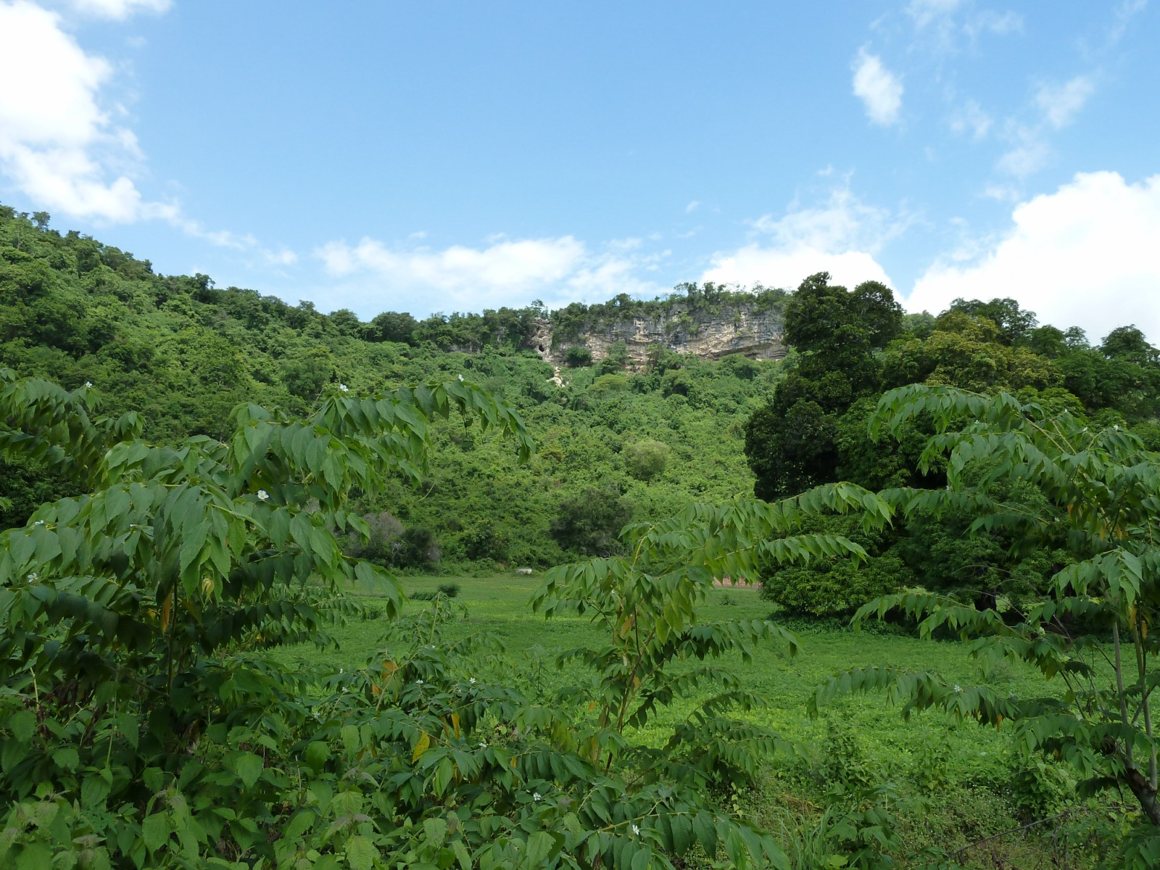
Fig. 1: Position of Takream Cave (red circle)

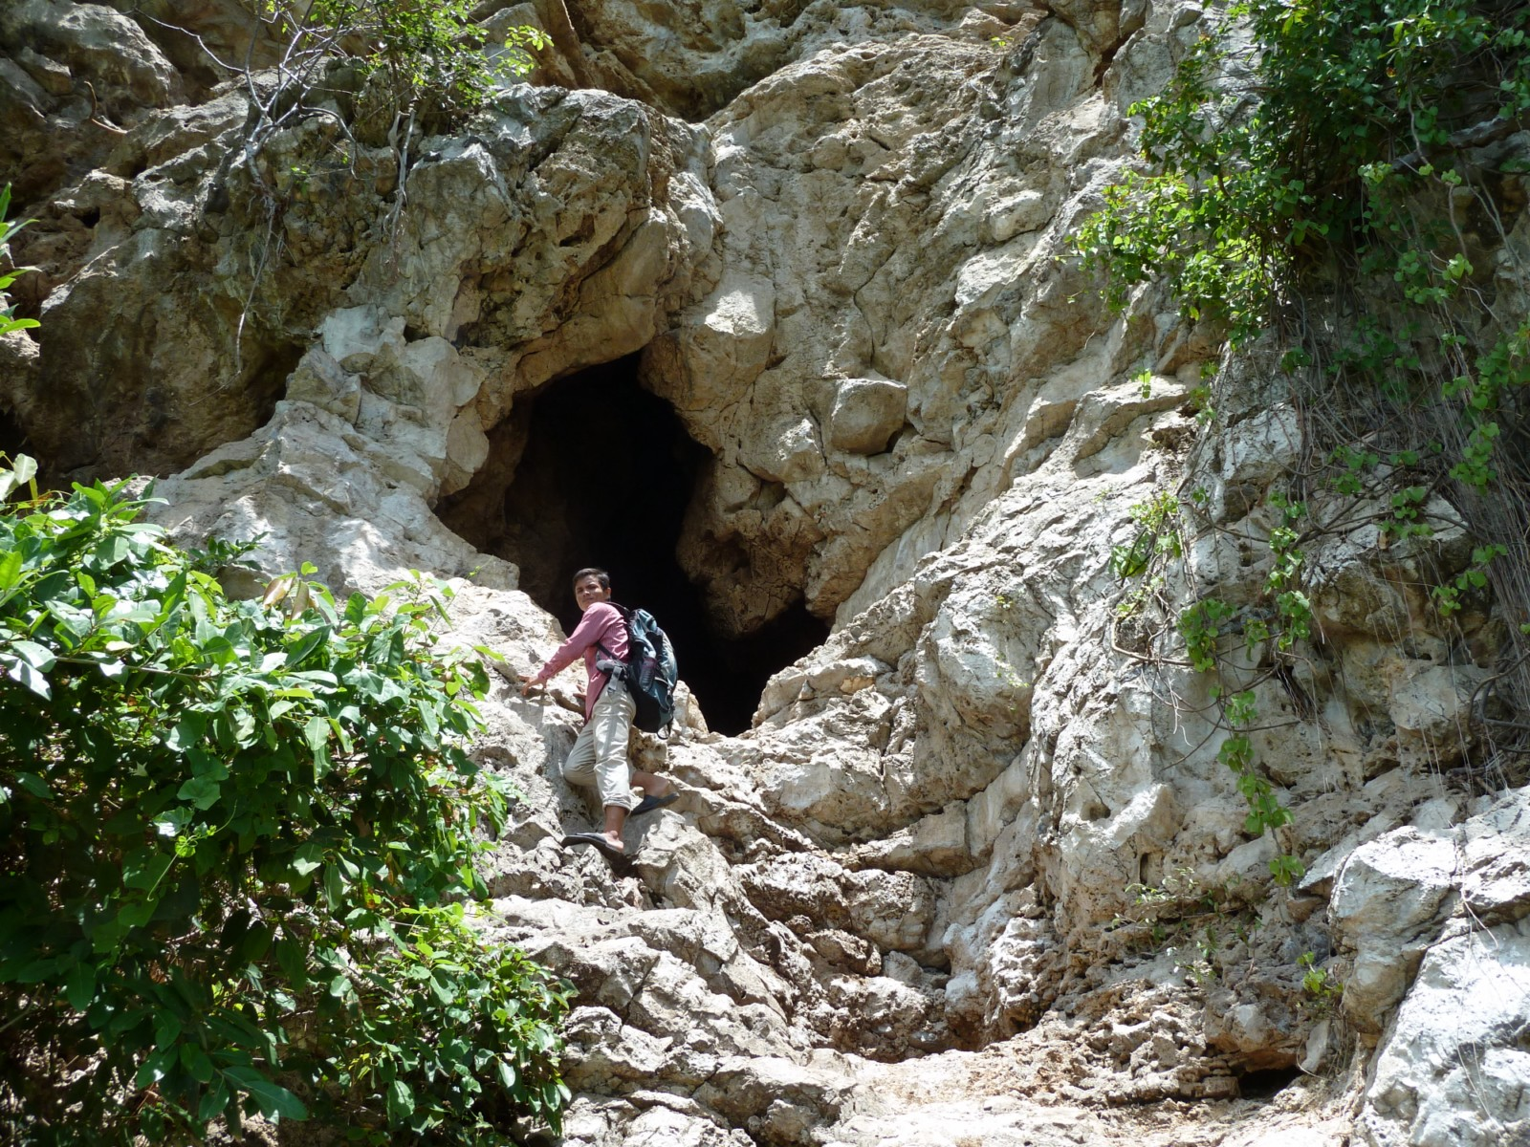
Fig. 2: Entrance to Takream Cave

